Technical Datasheet 4G Gateway
Product Overview: -
The 4G Gateway is an advanced networking device designed to provide seamless connectivity and data management capabilities for various applications. With support for 4G LTE connectivity, cloud connectivity via MQTT protocol, and robust storage options, it offers a comprehensive solution for remote monitoring and control systems. Equipped with Modbus RS485 port and micro Sim compatibility, it caters to a wide range of industrial and IoT applications. The intuitive web-based UI interface allows for easy configuration and management, making it an ideal choice for both professionals and enthusiasts.
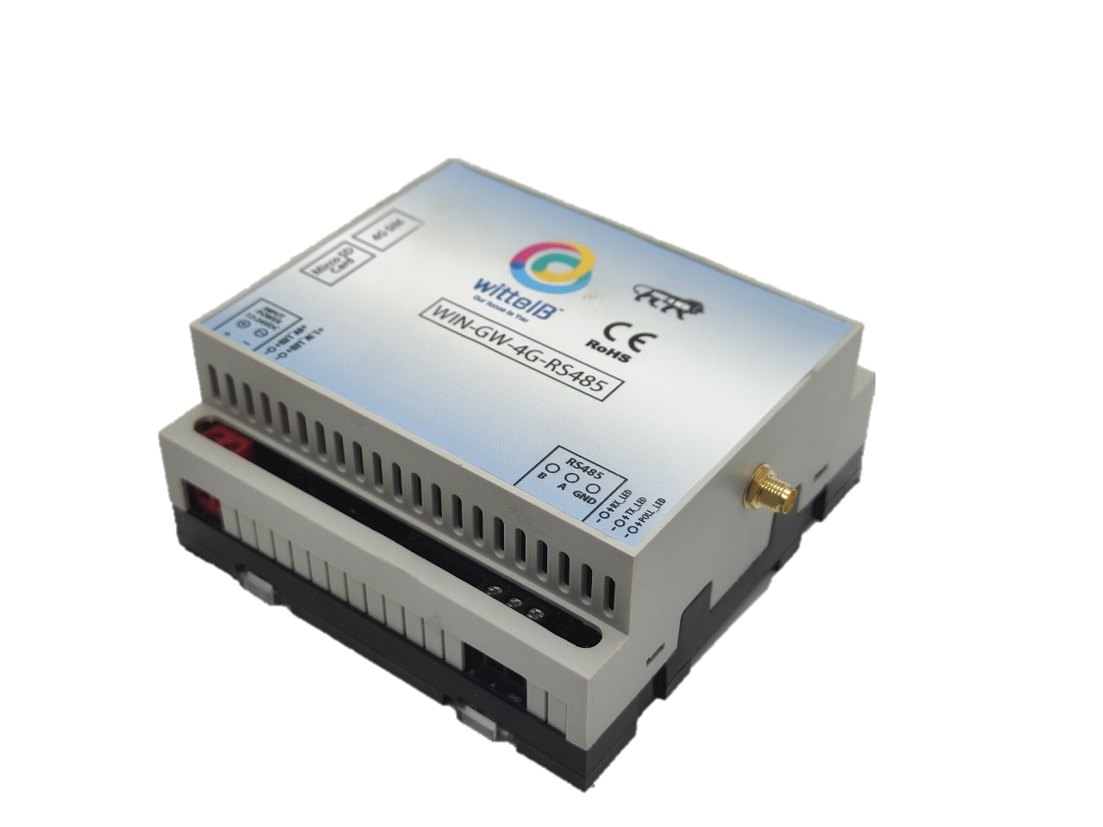

Specifications

General –
•4G LTE Connectivity: Utilizes 4G LTE technology for reliable and high-speed internet access.
•Cloud Connectivity (MQTT): Seamlessly connects to cloud platforms using the MQTT protocol for efficient data transmission and management.
•Event Storage: Offers on board event storage, capable of storing up to 50,000 events or more. Includes an external memory card slot for easy data retrieval in the event of 4G network issues.
•Modbus RS485 Port: Features 1 port of Modbus RS485 for integration with industrial control systems and sensors.
•GPS Location Data: Provides GPS location data for monitoring of remote equipment.
•Micro Sim Compatibility: Supports micro-Sim card for flexible and convenient connectivity option.
•Web-based UI Interface: Intuitive web-based user interface for easy configuration, monitoring, and management.
•Dimensions: 110 mm L x 110 mm B x 50 mm H.
•Power: Input Power – 15-40 VDC, Typical – 12V DC @ 150mA.
•Operating Temperature: 0 – 60C (32 ~ 140F).
•Storage Temperature: 20 - 70C (-4 ~ 158F).
•Storage Humidity: 5 ~ 95 % RH, non – Condensing.

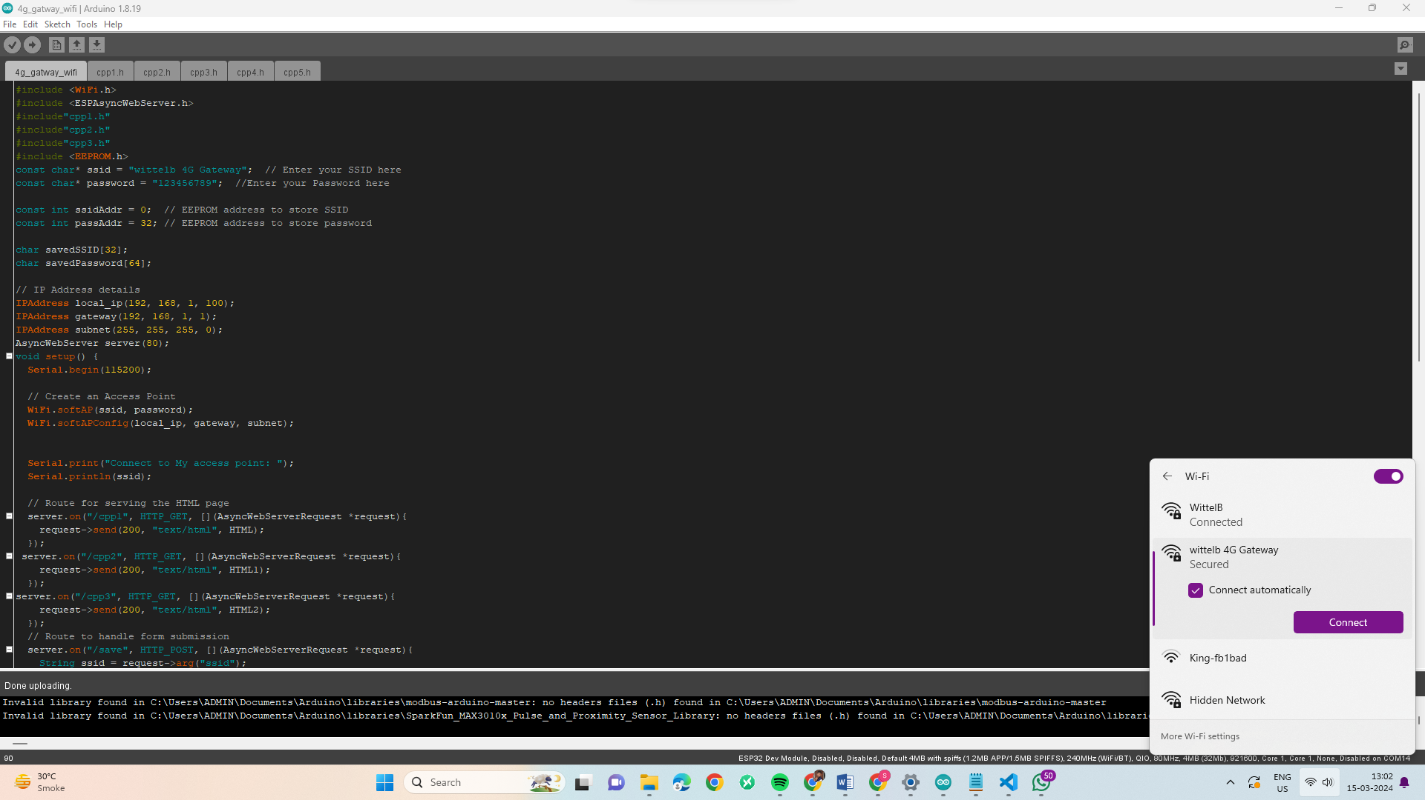
Configuration Settings: -
- Power up the module by connecting a 12 V DC supply.
- Insert the SIM card into the designated slot.
- Place the Micro SD card into its designated slot.
- Connect MODBUS RTU Multiple Slave devices (up to 5) to the A & B Terminal
Of Module.
- Access the module's configuration hotspot
(ID: Wittelb-4G-GATEWAY, PASS: 123456789).
- Default IP Address of Module is “192.168.1.100/cpp1”.
- Upon entering the provided IP address, a configuration webpage
Pages will be accessible.

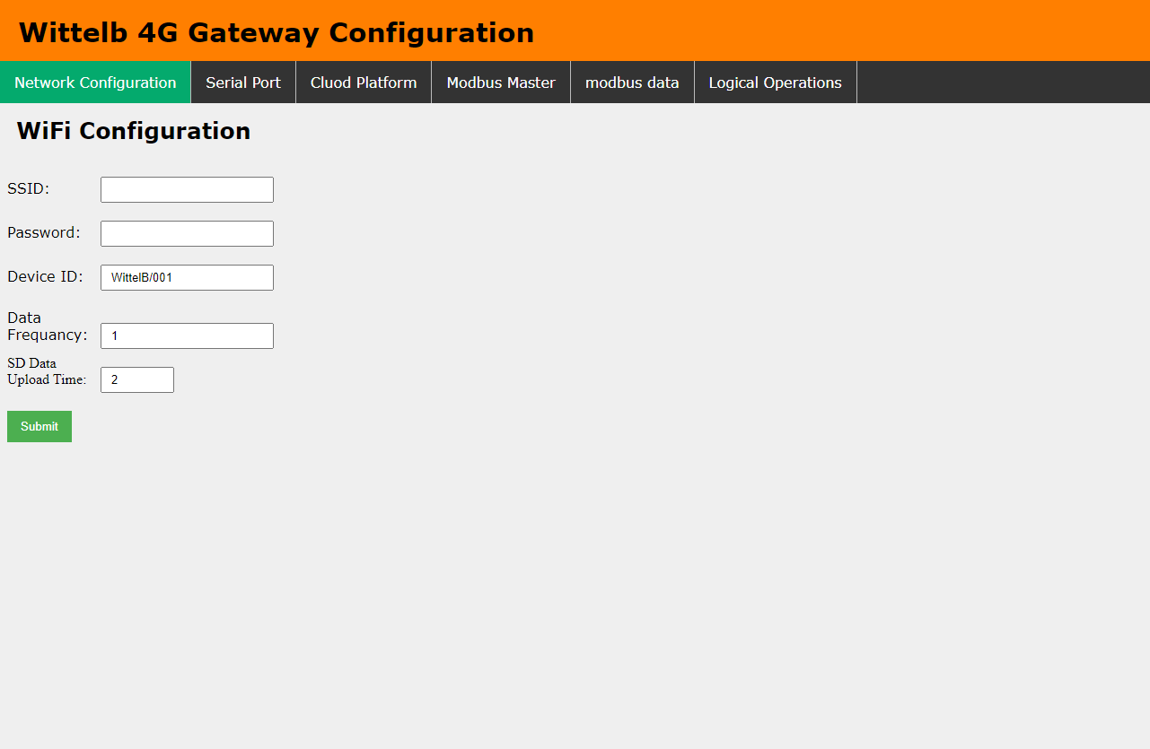
Page 1: -
- Enter Device ID (Should be unique for every device).
- Enter data frequency in min to receive data on cloud.
- Enter time to upload SD card data to cloud.
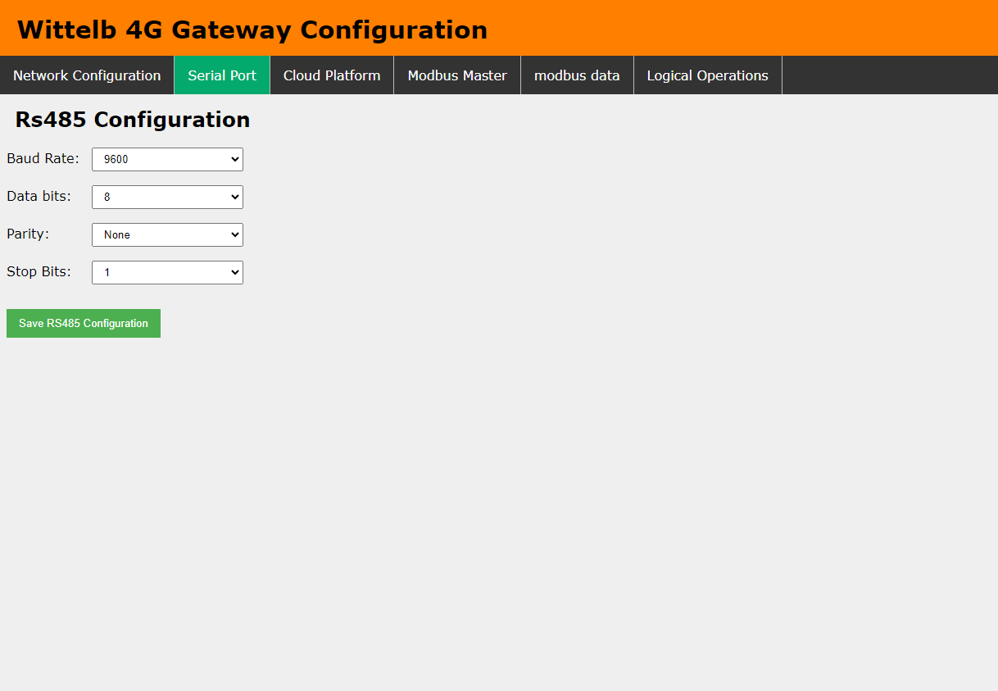
Page 2:- On second page you can set device Baud rate,Parity,Data Bits for RS485 Communication
Page 3:-
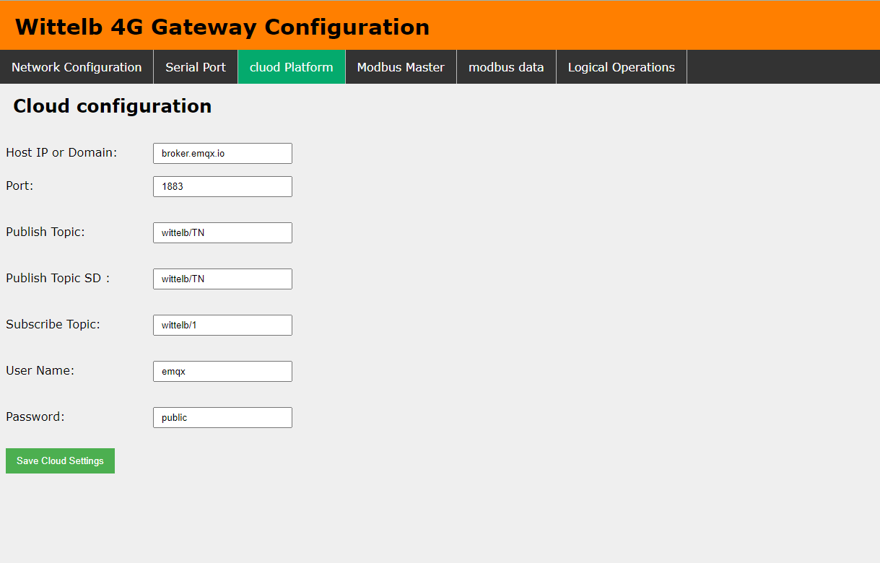
      - Navigate to page 3 on the cloud platform.
      - Input the Host IP or Domain.
      - Enter the port Number.
      - Enter the topics for publishing and receiving messages.
      - Provide a username and password if required.
      - Allow a few seconds for the module to restart and establish a connection to MQTT.

Page 4:-
- Go to page 4 on the Modbus Master interface.
- Input the name and slave address for the designated slave.
- Specify the register address from which you want to read slave data.
- Indicate the register end address for the slave.
- Enter the function code corresponding to the desired slave.
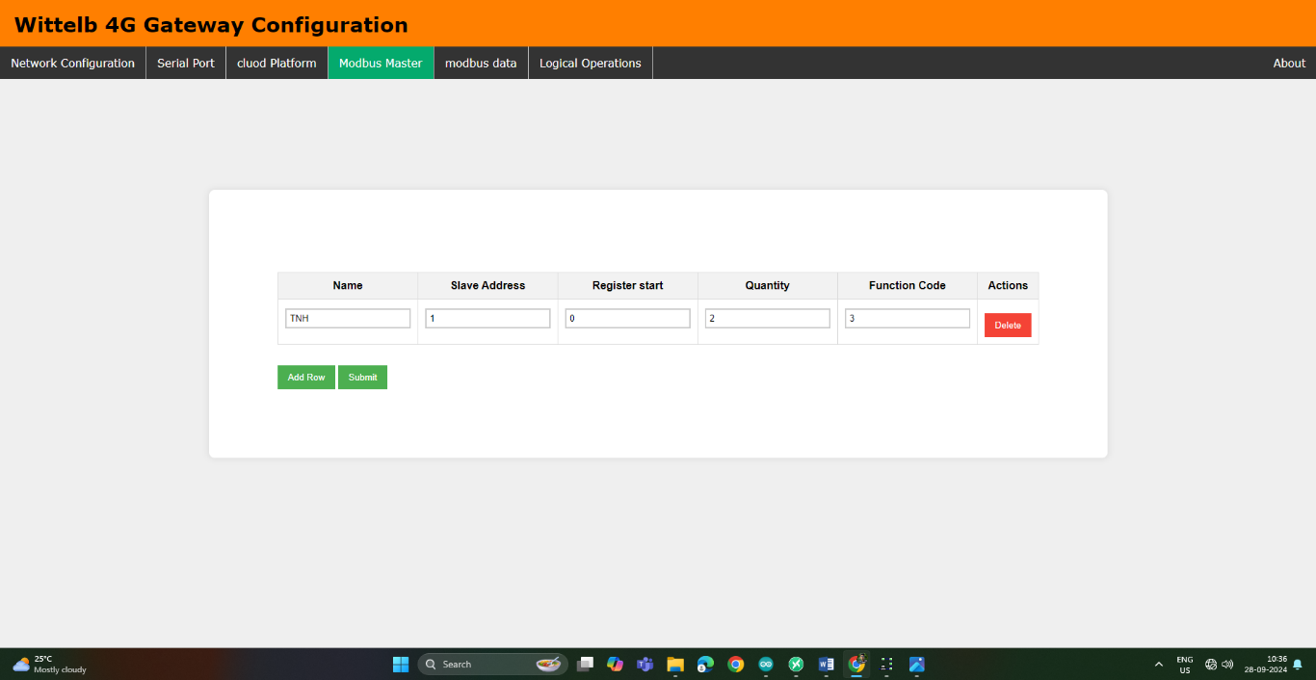
Page5:-
  - On page 5, you can query each slave to retrieve real-time data.
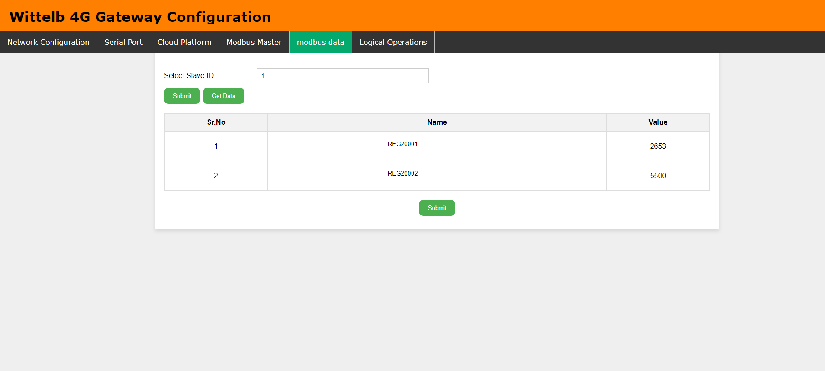
  - You can also rename the register to match your data point name.

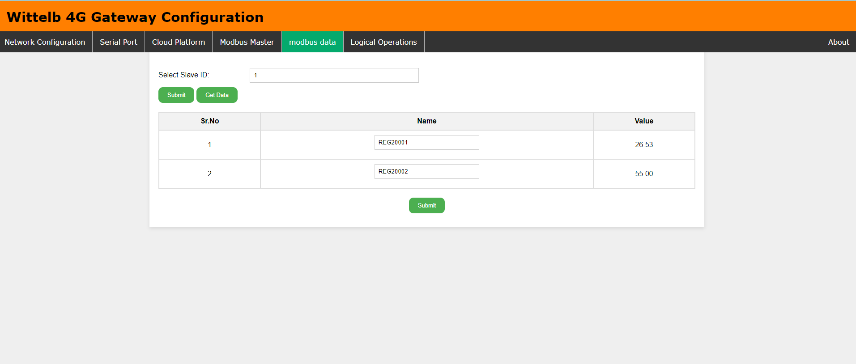
Page 6:-
  - On page 6, set the offset value to the actual value.
  - Enter the slave ID and specify the desired arithmetic operation.
  - Input the register address configured on the previous page.
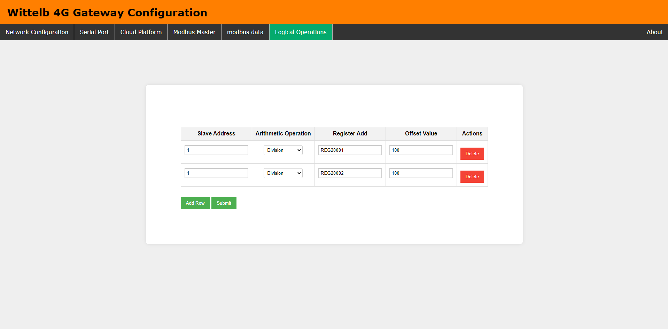
  - Enter the offset value, and the data will be sent to your cloud.
  - The above image shows data after performing the arithmetic operation with the
Offset value applied

4G Gateway connection Diagram: -
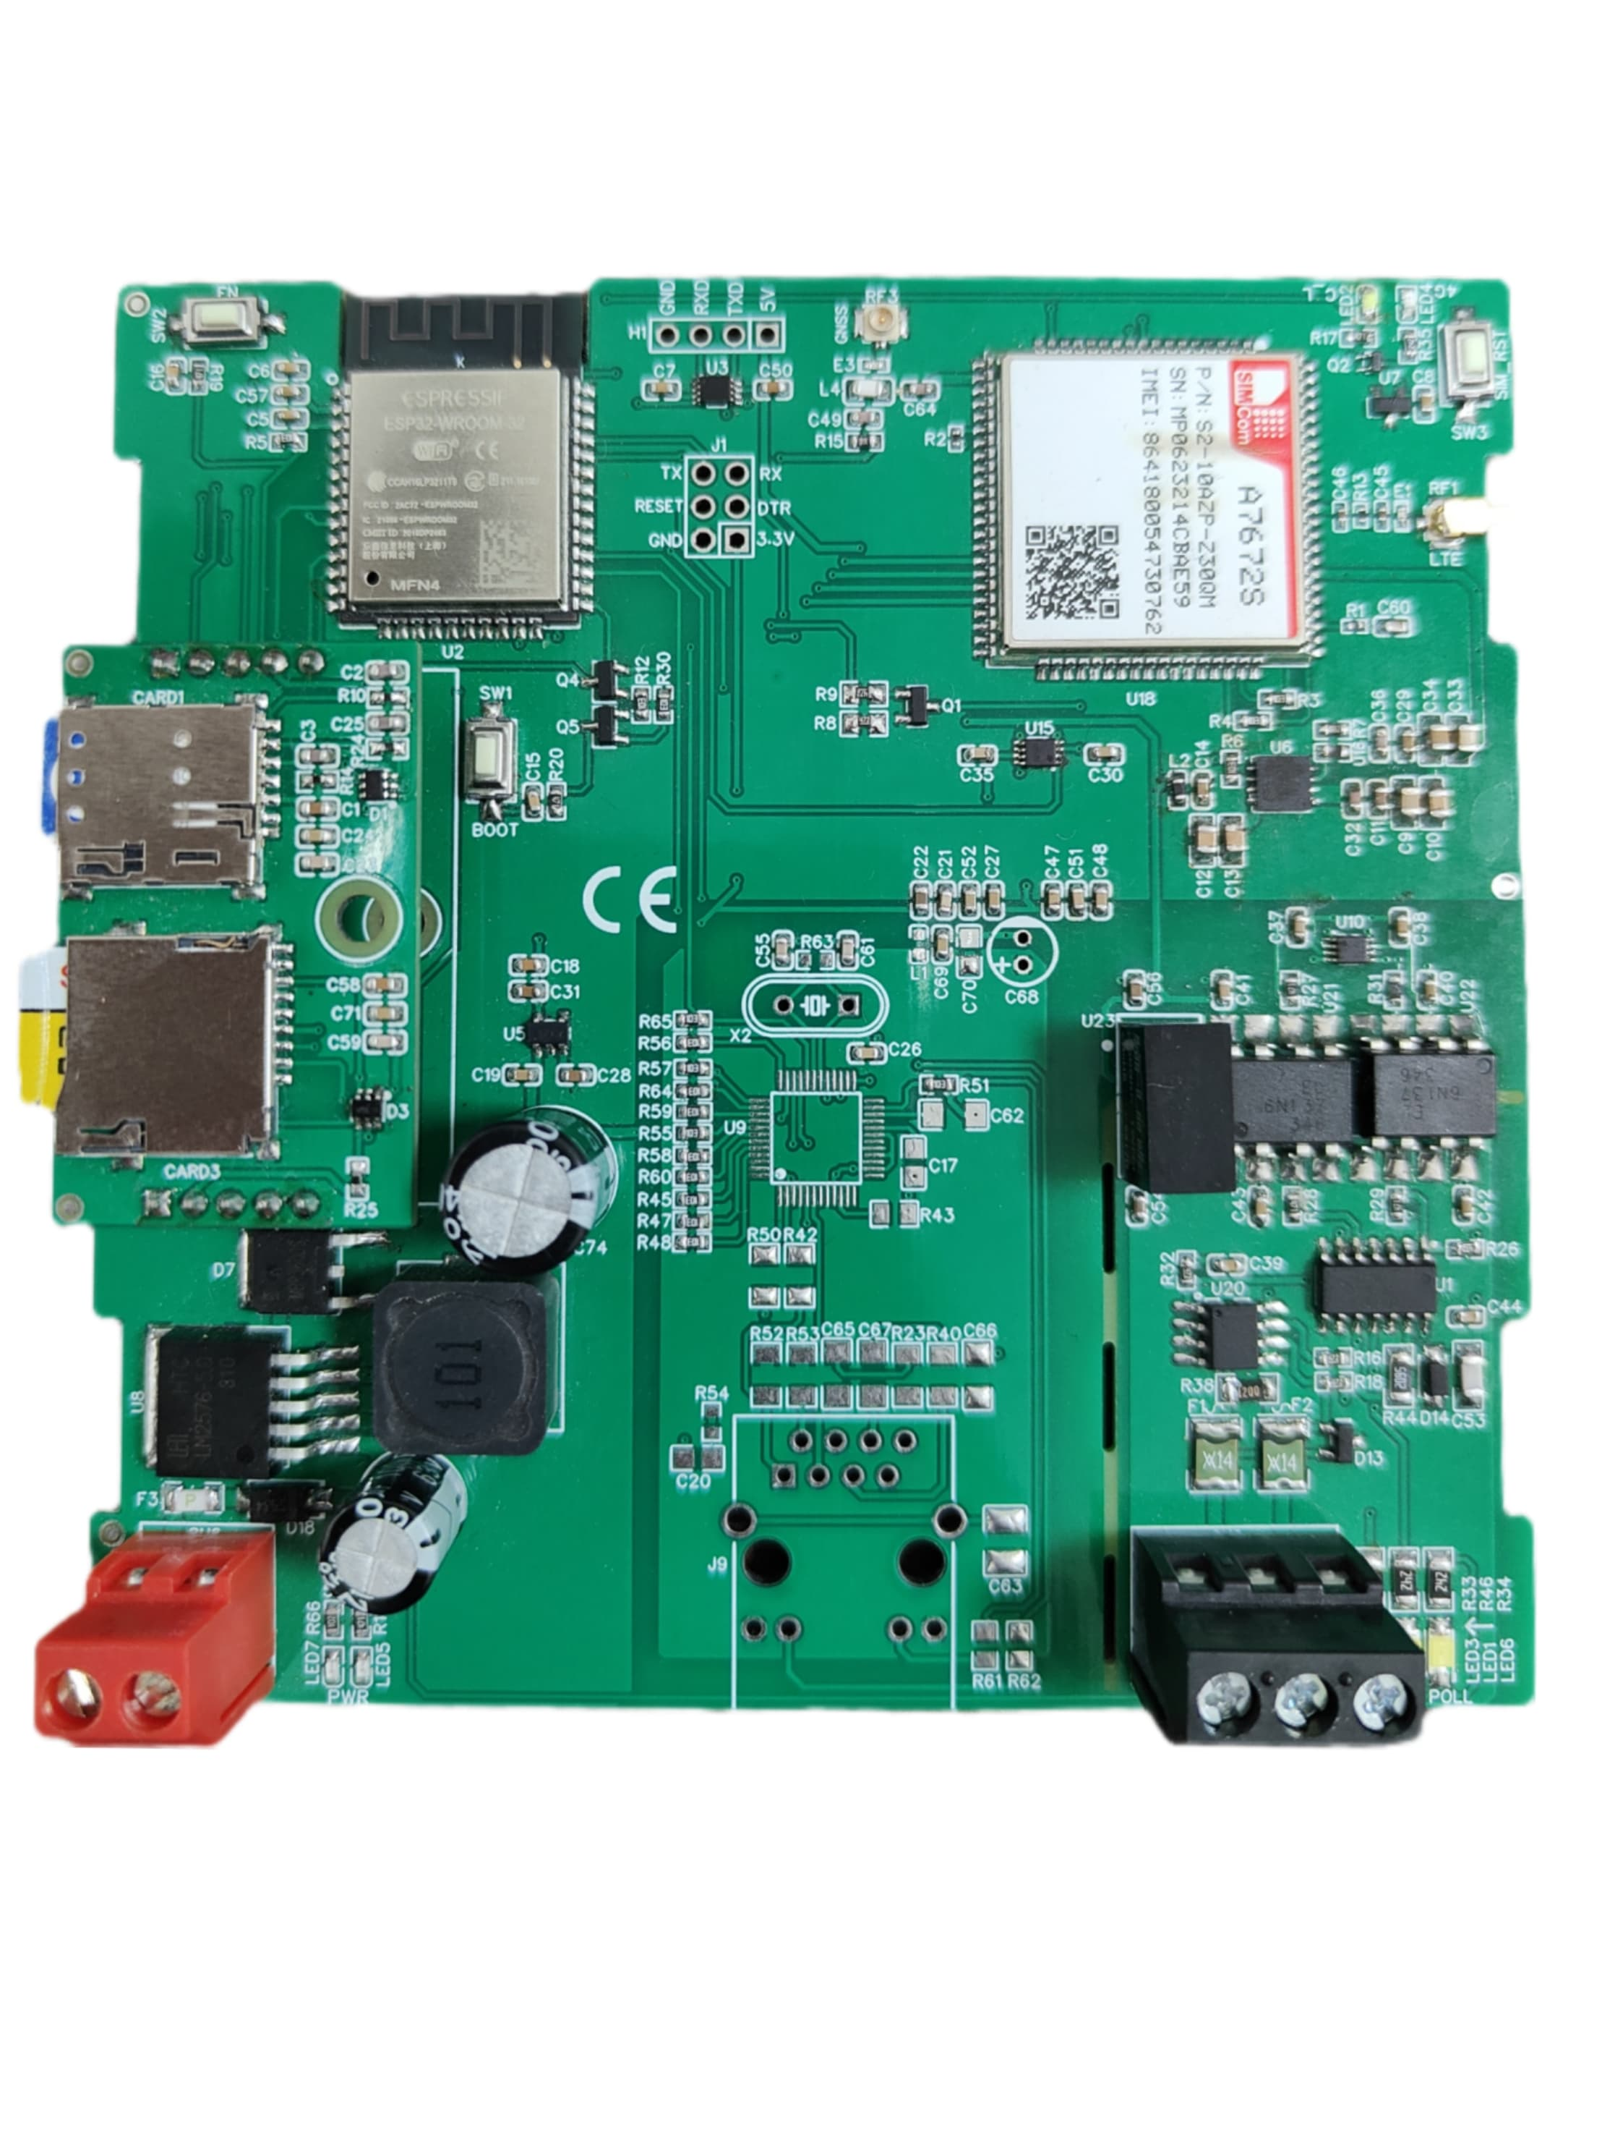
Network
Led

Sim Card Slot

SD Card Slot

RS485 & Polling Led

Power Connection and Power Led

Additional Features: -
Communication ports are isolated
Input power reverse polarity safety
ESD Safety IEC 61000-4-2, ± 30KV contact, ± 30KV air
EFT IEC 61000-4-4, 50A (5/50ms) 400V isolation.

Contact us: -
Augmatic Technologies Pvt. Ltd.,
Plot no 6, Shah Industrial Estate II,
Kotambi,
Vadodara – 391510.
Email – Sales@wittelb.com
Support: support@wittelb.raiseaticket.com / +91 94038 92805

